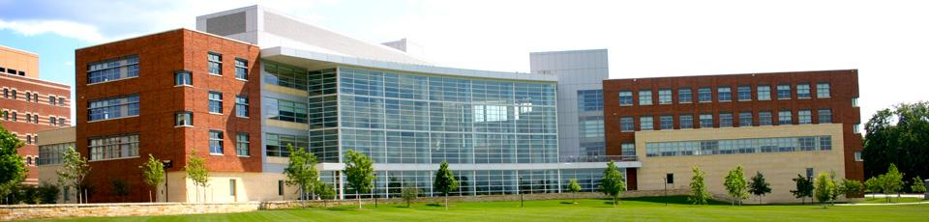
Smeal Student Mentors
Application 2016
IMPORTANT NOTICE
Freshmen applicants must already be in the Smeal College of Business and have a Cumulative GPA of 3.5 or higher to apply. Sophomore applicants must be either in Smeal or be a DUS student tracking Smeal with a cumulative GPA of 3.2 or higher. If you do not meet these requirements you cannot apply to become a Smeal Student Mentor.

Are you looking to get involved at Penn State and don't know how to? Do you remember how overwhelming arriving at University Park campus was your first year? Would you like to help incoming students feel a little more at home when they arrive on campus next fall? If you answered YES to any of the above questions, then we have the opportunity for you!

Smeal Student Mentors is a Smeal organization which prides itself on providing mentors for the incoming business students. As a mentor, you will be able to help your group of mentees feel more comfortable arriving at Penn State, share your knowledge of the campus, and receive leadership training and professional development. Before you apply we would like to let you know some of our goals for the upcoming year.

2016 Structure and Goals

Next year, we want to provide the best mentoring we can to the first-year students. We will prepare you as a mentor to answer the most frequently asked questions of incoming first-year students, and give you the opportunity to make a difference in someone's life by helping new students feel more comfortable. You will be their first new friend here at University Park and will be a great resource for them.

Each mentor will belong to a team; this team will be your base throughout the school year to help answer questions, coordinate meetings with your first-year students, and create personal relationships with other members of the organization. Each team has a Team Leader, to whom you will be able to look to for guidance, and experience. The spring team training sessions are designed to enhance your problem solving, communication, leadership and decision-making skills. Our goal through the training sessions is to make you a more effective mentor and proactive team player.

The primary goal of the Smeal Student Mentors is to be mentors, but our organization is also striving to provide more professional development. The Smeal Student Mentors will offer you many opportunities, but above all will give you the opportunity to get involved with the Smeal College of Business and to help new Penn State students.

-Smeal Student Mentors Board of Directors

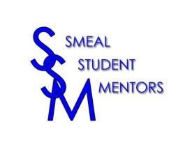
Responsibilities of a Mentor

- Meet with your mentees on a monthly basis.
- Attend all monthly General meetings.
- Attend Training and Team Building sessions in the spring.
- Contact your mentees regarding monthly meetings and important social events and dates. (i.e. - birthday wishes, late drop deadline, scheduling social)
- Communicate with your mentees on a regular basis
- Keep all information discussed with your mentees CONFIDENTIAL. Do not discuss with anyone other than your assigned team leader, or in serious cases, the advisor to the organization.
- Attend all meetings called by your Team Leader and fulfill all requirements of the committee(s) on which you serve.
- Participate in both the Snack and Schedule and the Phone-a-thon.
- Recognize the dues for 2016 will be $40.
- YOU MUST ATTEND THE FALL FIRST-YEAR STUDENT ORIENTATION (August 21, 2016).

Application Process

- Copy and paste the application into Microsoft Word and complete it.
- Print out the application and submit by 5:00 PM on Friday, February 26th, 2016 at the front desk in 202 Business Building.
- You must get a teacher or advisor to sign the recommendation letter (found at the end of this application) and have it sent directly to Alla Hatfield, either by mail to 202 Business Building or email to anh130@psu.edu. This is due no later than Friday, Thursday 26th, 2016 by 5 PM.
- We will be conducting 15 minute interviews with applicants on March 15, 2016 from 4:30 to 10:00, March 16, 2016 from 4:30 to 10:00 and March 17, 2016 from 4:30 to 10:00.
- Dress for the interview is business casual.
- We will notify you by Friday, March 4, 2015 of your interview time.

There will be three mandatory meetings for all mentors as listed below, please mark your calendar now. If accepted, we will follow-up with you with more specific details.

Mentoring Training Session Monday, April 4, 7 pm, 110 Business Building

Mentor Team Building Tuesday, April 12, 7 pm, Business Building Lawn

General Membership Meeting Monday, April 25, 7 pm, 110 Business Building

We would like to thank you for applying and we look forward to working with you next year!

Please find the application on the following pages and follow the instructions for submission. Please answer all questions. All answers must be TYPED. Please return to the drop off box at the front desk in 202 Business Building by 5:00 PM on Thursday, February 26th, 2016. If you have any questions, please contact: Reid Worster at rxw5212@psu.edu

Smeal Student Mentors Application
2016

Please answer all questions. All answers must be TYPED. Please return to the drop off box at the front desk in 202 Business Building by 5:00 PM on Thursday, February 26th, 2016. Applications turned in after this time will not be considered. If you have any questions, please contact: Reid Worster at rxw5212@psu.edu. aas5005@psu.edu

Name_________________________________________________
Penn State Email ________________________________________
T-Shirt Size _____________________________________________
Year/Major _____________________________________________
(i.e. Sophomore/BA, Sophomore/DUS, Junior/Marketing)

GPA ____________ / 4.00
Cell Phone Number ______________________________________

Part 1: Personal Information

1. Were you a freshman at the University Park campus? Yes ____No____

2. Will you be going abroad or on a co-op during Fall 2016 or Spring 2017?
Fall 2016? Yes ______ No _______
Spring 2017? Yes ______ No _______

3. List any honors, mentoring experience, and leadership
positions you have held or are currently holding:

4. Think back to your freshman year. What was the biggest problem or
obstacle that you encountered? How did you overcome it?

5. Are you involved with any other clubs or organizations on or off campus? If yes,
please explain.

Part 2: Mentoring Questions

6. In your own words, define the role and responsibility of being a mentor.

7. How could you encourage your mentees to attend meetings and other events?

8. What is the best advice you could give to an incoming freshman?

9. How did you become interested in the Smeal Student Mentors? Do you have any
friends who are already Mentors?

10. Why do you want to become a Smeal Student Mentor?

Please attach a picture of yourself below so that we can get to know you better:

Please list times you will be available to attend a 15 minute interview during the following times:
March 15, 2016 from 4:30 to 10:00
March 16, 2016 from 4:30 to 10:00
March 17, 2016 from 4:30 to 10:00
(i.e. 5-7 PM Tuesday and 7-9 PM Wednesday)
1.)
2.)
3.)

I _______________________________ (print name) have read all of the roles and responsibilities expected of all Smeal Mentors. I have also taken note of the mandatory events and, by submitting this application, attest to the fact that I can attend all of them. Also, I affirm that all of the information I have provided is accurate.

Signature: _______________________________________ Date: _______

If selected to be a Smeal Student Mentor, you will be required to pay a membership fee. This includes the cost of a Smeal Student Mentor T-Shirt and Polo, which is required for all events. Please direct any questions regarding fees to Tommy Radziminski at tar5324@psu.edu.

Please return to the front desk staff in 202 Business Building by:

5:00 PM on Thursday February 26, 2016
If you have any questions, contact Reid Worster at rw5212@psu.edu

** You will be notified of interview times by Friday March 4, 2016**

Please find the faculty/advisor endorsement on the next page.
This needs to be submitted to Alla Hatfield (anh130@psu.edu) no later than Thursday, February 26th, 2016.

Faculty/Advisor Endorsement-
Applicants: please complete the top portion of the form and drop it off to a faculty member OR advisor for them to complete.
The form is due Thursday, February 26th. The form can be emailed to Alla Hatfield at anh130@psu.edu or mailed to Alla Hatfield at 202 Business Building. Late forms will not be accepted and will result in students not being eligible for the interview.

Student Name: _________________________ PSU Email Address:
To the Faculty/Advisor,
The purpose of this form is for you to give your recommendation on behalf of this student to the Smeal Student Mentors as we complete our recruitment process. The Smeal Student Mentors are a student organization that is responsible for mentoring the incoming first-year business students. We are dedicated to recruiting Smeal students (or DUS students tracking Smeal) that are responsible, enthusiastic, organized, and a good role model for the first-year students.
If you have agreed to complete this endorsement form for the above mentioned student, please know that he or she will not see what you have written. Please send the completed form directly to the organization’s advisor: Alla Hatfield, (202 Business Building or (anh130@psu.edu). If you have any questions regarding the organization, this form, or the process, please email anh130@psu.edu
We would appreciate it if you could take a few minutes to answer the following questions. One or two sentences will be sufficient, no need for a formal letter. Thank you in advance for your assistance, your input is extremely valuable as we have a very competitive application process.
Faculty Name: Title: PSU Email Address: ______
- How long have you known this student and in what capacity?
- What do you see as this student’s greatest strengths?
- Do you believe that this student would be a good role model to first-year students?
- In your opinion, is this student organized, dedicated, and enthusiastic?
- Do you have any reservations about recommending this student?
- Any other information that you might like to share.

